Dear Cesar,

Here’s the message from Credit Suisse:

Below I send the developer's task to do by the candidate. The source code of this task we would like the candidate to provide until 11/04/2017 EOD so that we can  review the solution before the interview. At the Skype call we will be expecting him to demo us his application and we will do small pair-programming.

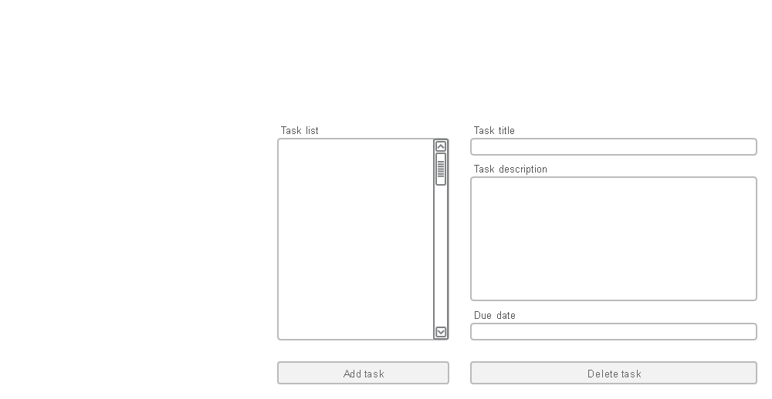

And here is the task ( the mockup in the attachment, which shows how should look the main page and how should look the popup):

Create simple TODO application.

General:

-          Application should be written using Java 8, JSF and PrimeFaces

-          Application contains two parts: main application page (see: main.png) and pop up (see: popup.png)

-          We are not specifying in details which GUI components to use - candidate should select PrimeFaces components that fits best for given task (see: <https://www.primefaces.org/showcase/> for list of possible components)

-          There is no need for real persistence layer – simple in memory storage is enough

-          This task is focused around Fronted development, but we should be able to see that Candidate understands separation between frontend and backend, so all source **should not** be inside “one class”

Main application window:

-          Contains list of task on the left and task details on the right

-          When user selects task in the list on the left, details of given task should be visible on the right

-          Details on the right should contains GUI components that are **disabled**

-          Delete button on the bottom of task description should remove task from the list and make details empty

-          Clicking add task button should open pop up that allows user to add task

Pop up:

-          Pop up allows one to add new task

-          Each time pop up is open it should be empty

-          Submit button should add task to list in the main page, cancel should close window without adding task

-          Due date should be some kind of date input, **not** the text field

